BIG MART SALES DATASET

ABSTRACT
Everybody wants to know how to buy goods cheaper or how to advertise them at low cost. Here is the answer. That is Big Mart. Big Mart is online one stop marketplace where you can buy or sell or advertise your merchandise at low cost. The goal is to make Big Mart the shopping paradise for buyers and the marketing solutions for the sellers. The ultimate goal is to prosper with customers. The project “BIGMART SALES DATASET” aims to build a predictive model and find out the sales of each product at a particular store. Big Mart will use this model to understand the properties of products and stores which play a key role in increasing sales. This can also be done based on the hypothesis that should be done before looking at the data.

INTRODUCTION
With the rapid development of global malls and stores chains and the increase in the number of electronic payment customers, the competition among the rival organizations is becoming more serious day by day. Each organization is trying to attract more customers using personalized and short-time offers which makes the prediction of future volume of sales of every item an important asset in the planning and inventory management of every organization, transport service, etc. Due to the cheap availability of computing and storage, it has become possible to use sophisticated machine learning algorithms for this purpose. In this paper, we are providing forecast for the sales data of big mart in a number of big mart stores across various location types which is based on the historical data of sales volume. According to the characteristics of the data, we can use the method of multiple linear regression analysis and random forest to forecast the sales volume.

SYSTEM ANALYSIS
EXISTING SYSTEM
With the rapid development of global malls and stores chains and the increase in the number of electronic payment customers, the competition among the rival organizations is becoming more serious day by day. Each organization is trying to attract more customers using personalized and short-time offers which makes the prediction of future volume of sales of every item an important asset in the planning and inventory management of every organization, transport service, etc. Due to the cheap availability of computing and storage, it has become possible to use sophisticated machine learning algorithms for this purpose.
PROPOSED SYSTEM
The data scientists at Big Mart have collected 2013 sales data for 1559 products across 10 stores in different cities. Also, certain attributes of each product and store have been defined. The aim is to build a predictive model and find out the sales of each product at a particular store. Using this model, Big Mart will try to understand the properties of products and stores which play a key role in increasing sales.
ADVANTAGES:
- This is an easily scalable model to provide detailed information and accurate predictions for sales volume for different types of products as there is a lot of data out there.
- It is the percentage of display space in a store given to that particular item. Looking at the average visibility of items given in each store type and outlet.

SYSTEM REQUIREMENTS

HARDWARE REQUIREMENTS
MINIMUM (Required for Execution) |  | MY SYSTEM (Development)
System | Pentium IV 2.2 GHz | i3 Processor 5th Gen
Hard Disk | 20 Gb | 512 Gb
Ram | 1 Gb | 4 Gb

SOFTWARE REQUIREMENTS
Operating System | Windows 10/11
Development Software | Python 3.7.0
Programming Language | Python
Integrated Development Environment (IDE) | Python IDE
Design/Modelling | Rational Rose
Tool | Jupiter NoteBook

SYSTEM ARCHITECTURE
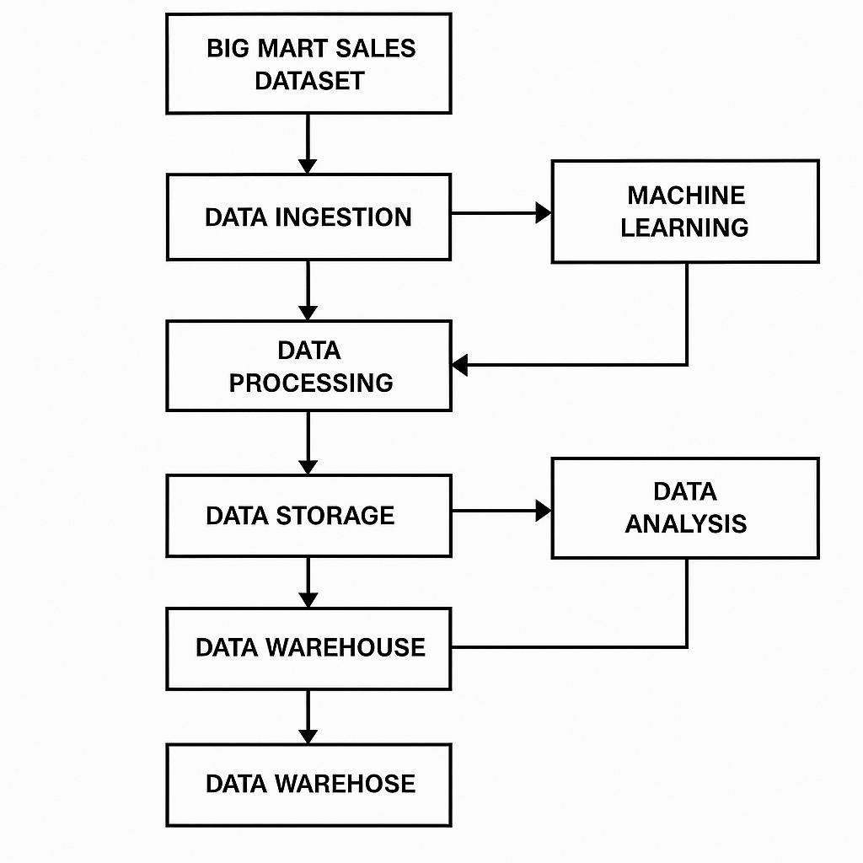

MODULES
- USER

